8.14 Main question

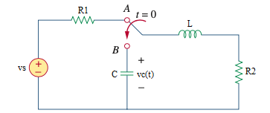

Given *Vs* = 80 V, *R*1= 30 Ω, *R*2= 10 Ω, *L* = 4 H, *C* = 1/4 F.

Find

Variables

Random variables

vs = {10:100};

r1 = {20:40};

r2 = {5:15};

c = {0.25:1:0.25};

Global variables

vs = 80; r1 = 30; r2 = 10; c = 1/4;

l = 4; time = 1;

# t = 0-

vc0 = 0;

il0 = vs/(r1+r2);

# t = 0+

ic0 = -il0;

dvc0 = ic0/c;

req = r2

alpha = req/(2*l);

w0 = 1/sqrt(l*c);

s1 = -alpha+sqrt(alpha*alpha - w0*w0);

s2 = -alpha-sqrt(alpha*alpha - w0*w0);

A1 = ((s2*vc0)-dvc0)/(s1-s2);

A2 = vc0-A1;

vct = A1*exp(s1*time) + A2*exp(s2*time);

Part (กรอกคำตอบ)

1. *α* = alpha = 1.25 s^-1

2. *ω*0 = w0 = 1 rad/s

3. *vC*(0+) = vc0 = 0 V

4. *iL*(0+) = il0 = 2 A

5. *dvC*(0+)/*dt* = dvc0 = 8 V/s

At *t* > 0

6. *vC*(*t*) = A1*exp(s1*t) + A2*exp(s2*t)

= 5.33*exp(-0.5*t) - 5.33*exp(-2*t)V

7. *vC*(time*τ*) = vct = 2.51 V

8.17 Main question

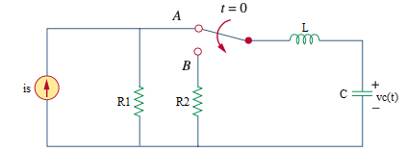

Given is = 5 A, r1= 4 Ω, r2= 10 Ω, c = 0.04 F, l= 0.25 H

Find

Variables

Random variables

is = {1:5};

r1 = {1:5};

r2 = {8:15};

c = {0.01:0.05:0.01};

Global variables

#is = 5; r1 = 4; r2 = 10; c = 0.04;

l = 0.25; time = 1;

# t = 0-

il0 = 0;

vc0 = is*r1;

# t = 0+

alpha = r2/(2*l);

w0 = 1/sqrt(l*c);

s1 = -alpha+sqrt(alpha*alpha - w0*w0);

s2 = -alpha-sqrt(alpha*alpha - w0*w0);

A1 = (-vc0/l)/(-s1+s2);

A2 = (-vc0/l)/(s1-s2);

ilt = A1*exp(s1*time) + A2*exp(s2*time);

Part (กรอกคำตอบ)

1. *il*(0-) = il0 = 0 A

2. *il*(0+) = il0 = 0 A

3. *α* = alpha = 20 s^-1

4. *ω*0 = w0 = 10 rad/s

At *t* > 0

5. *il*(*t*) = A1*exp(s1*t) + A2*exp(s2*t)

= 2.309*exp(-2.679*t) - 2.309*exp(-37.32*t) A

6. *il*(time*τ*) = ilt = -0.1585 A

8.24 Main question

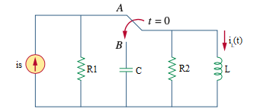

Given is = 4 A, r1= 20 Ω, r2= 5 Ω, c = 10 mF, l= 2 H

Find

Variables

Random variables

is = {1:5};

r1 = {1:20};

r2 = {1:5};

l = {2:5};

Global variables

#is = 4; r1 = 20; r2 = 5; c = 10e-3;

l = 2; time = 1;

# t = 0-

il0 = is;

# t = 0+

rth = r2;

alpha = 1/(2*rth*c);

w0 = 1/sqrt(l*c);

s1 = -alpha+sqrt(alpha*alpha - w0*w0);

s2 = -alpha-sqrt(alpha*alpha - w0*w0);

A1 = (-4*s2)/(s1-s2);

A2 = (-4*s1)/(-s1+s2);

ilt = A1*exp(s1*time) + A2*exp(s2*time);

Part (กรอกคำตอบ)

1. *il*(0-) = il0 = 4 A

2. *il*(0+) = il0 = 4 A

3. *α* = alpha = 10 s^-1

4. *ω*0 = w0 = 7.07 rad/s

At *t* > 0

5. *il*(*t*) = A1*exp(s1*t) + A2*exp(s2*t)

= 4.82*exp(-2.92*t) – 0.82*exp(-17.07*t) A

6. *il*(time*τ*) = ilt = 0.26 A

8.25 Main question

Given vs = 30 V, r1= 2 Ω, r2= 8 Ω, c = 1/4 F, l= 1 H

Find

Variables

Random variables

vs = {10:20};

r1 = {2:5};

r2 = {2:5};

l = {5:10};

Global variables

#vs = 30; r1 = 2; r2 = 2; c = 1/4;

l = 5; time = 1;

# t = 0-

il0 = vs/(r1+r2);

vc0 = r2/(r1+r2)*vs;

# t = 0+

rth = r2;

alpha = 1/(2*rth*c);

w0 = 1/sqrt(l*c);

s1 = -alpha+sqrt(alpha*alpha - w0*w0);

s2 = -alpha-sqrt(alpha*alpha - w0*w0);

A1 = (-15*s2)/(s1-s2);

A2 = (-15*s1)/(-s1+s2);

vct = A1*exp(s1*time) + A2*exp(s2*time);

Part (กรอกคำตอบ)

1. *vc*(0-) = vc0 = 15 V

2. *vc*(0+) = vc0 = 15 V

3. *α* = alpha = 1 s^-1

4. *ω*0 = w0 = 0.89 rad/s

At *t* > 0

5. *vc*(*t*) = A1*exp(s1*t) + A2*exp(s2*t)

= 24.27*exp(-0.55*t) – 9.27*exp(-1.44*t) V

6. *vc*(time*τ*) = vct = 11.8 V